TERMINOLOGY used in InCubed activities

Adoption
Refers to the uptake of solution by customers in a market. For example, a service that has high user adoption is in high demand among its users. A product that has rapid market adoption is experiencing strong customer purchases of the product. An example would be the rapid adoption of Apple’s iPhone and iPad.
Amortization
"Amortization" -- refers to method of allocating the cost of a intangible asset over that assets useful life (e.g. a patent cost spread along the patent output lifetime).

Adjacent Market
Adjacent Market segments share common characteristics with the existing targeted customer segments in terms of requirements, ecosystem, user community, relationships.
Business Model
The mechanism(s) by which an organisation generates revenue. There is a wide array of business models – some examples include monthly subscriptions to services, direct sales to organisations, channel resellers, technology licensing, etc. The choice of business model is critical to success in capturing the business opportunity. An organisation can have more than one business model to achieve its objectives.

Capital Expenditure (CAPEX)
Refers to funds used by a company to acquire or upgrade physical assets such as equipment, property, industrial buildings etc.
Channel
An organisation you form a partnership with to represent your solution in a specified market. Channel Partners can include: resellers, service providers, system integrators, distributors, etc.
Commercial Customer
An organisation that purchases a product to use in the operation of its business. This is in contrast to a User Customer who purchases for personal, non-business use. Commercial Customers have rational, profit-oriented behaviours while User Customers have personal, emotional behaviours.
Commercialisation
The process of turning an idea into a market success, by generating a positive return on investment or by creating a positive impact on the economic and social well-being of society.
Competitive analysis
The act of identifying the value point(s) in your solution that the target customer considers to be distinctive.

Competitor
Alternative entity that have products, systems, services and solutions that aim to create same value for the customer segments. Competition can exist between products with similar feature sets as well as substitute products with different feature sets.
Cost
In ESA terms, “cost” refers to the total cost of development including labour, travel, development tools, subcontractors, external services, etc.
Cost of Sales
The costs attributed to the production of a product. It includes direct material costs, direct labour, and overhead costs (as in absorption costing), and excludes operating costs OPEX (period costs) such as selling, administrative, advertising or R&D, etc.

Customer Gains
Benefits and desires, and may span personal, functional, or economical etc. For example, this box could include positive emotions, functional requirements, or specific cost savings.

Customer Jobs
Customer needs, the problems that they are trying to solve and the tasks they are trying to perform or complete.

Customer Pains
The negative emotions and undesired costs, situations and risk which the customer could experience before, during and after getting the job done.
Customer (Segments)
A Customer segment is an individual or organisation for whom are you creating value (solving the problems)
Differentiation
The process of distinguishing a solution or company from competitors by focusing on aspects (features) that are unique. Differentiation is about identifying the unique advantage in your solution – the "secret sauce" that customers value and that allows you to gain a competitive advantage.

Depreciation
Refers to method of allocating the cost of a tangible asset over its useful life. Businesses depreciate long-term assets for both tax and accounting purposes.
Discounted Cash Flow
Refers to a valuation method used to estimate the attractiveness of an investment opportunity. Discounted cash flow (DCF) analysis uses future free cash flow projections and discounts them (using the cost of capital) to arrive at a present value, which is used to evaluate how good is the potential for investment.
Earnings Before Interest & Tax (EBIT)
Refers to "Earnings Before Interest & Tax" An indicator of a company's profitability, calculated as revenue minus expenses, excluding tax and interest. EBIT is also referred to as "operating earnings", "operating profit" and "operating income".
ESA Price
The amount of ESA funding that can be granted to a successful bidder. In the InCubed activities, the ESA Price can be up to 50% of the cost (80% for SMEs).
Free Cash Flow
Refers to the cash that a company is able to generate after laying out the money required to maintain or expand its asset base. Free cash flow is important because it allows a company to pursue opportunities that enhance shareholder value.
Gain Creators
The features of your product that creates customer gain

Gross Margin
Gross Margin is a measure of the company's effectiveness in turning raw materials into income. It is calculated by subtracting Cost of Sales/Goods Sold from Gross Revenue. To express Gross Margin as a percentage, divide Gross Margin by Gross Revenue.

Industry
describes a specific grouping of companies with highly similar business activities.
In-kind Contribution
Please refer to the Part 7 of the Proposal Part 2 [Full] template.

Internal Rate of Return (IRR)
Refers to the rate of return used to measure and compare the profitability of investments. It is the value that the cost of capital has in order to have a NPV equal to 0.
Lead Customer
An early stage customer that is willing to work with you to help define and shape a product. into a commercially viable offering. Lead customers provide critical feedback in the commercialisation process and are willing to take the risk associated with early stage technologies.
Licence
Legal permission from a patent owner that allows a third party to use or practice an invention. Licensing technology is one way for inventors to commercialise their ideas.

Market
The market is the group (or groups) of customers who require the products and services.

Market Forces
The external uncontrollable forces that have an impact on an organisation conducting business in a given sector/industry – for example, market forces include events and trends in political, economic, social, technological and demographic. Market forces should be monitored and assessed in terms of their impact as an opportunity or threat to an organisation and its solution(s).
Market Share
The total sales of an organisation divided by the sales of the market it serves. This is one means of expressing the competitive position of a particular business, product or technology. It is a quantitative value, in contrast to mindshare, which is qualitative.
Net Present Value (NPV)
Net Present Value is an important value in discounted cash flow analysis, and is a standard method for using the time value of money to assess the viability of long-term projects. NPV reflects the fact that expenses or revenues that will not occur until sometime in the future should be discounted to reflect the impact of risk, interest, and inflation over that time period.
Non-Recurring Engineering Costs (NRE)
Non-recurring engineering costs refers to items that are one-time engineering costs associated with the project.
Original Equipment Manufacturer (OEM)
The original manufacturer of a component or system. The term OEM is used in several contexts – first, as defined above and second, to describe a customer who integrates another manufacturer's component into their branded system. An example of an “OEM customer” would be a smart phone device manufacturer purchasing the operating system software from an OEM.
Operating Expenses (OPEX)
Refers to those expenses that a business incurs as a result of performing its normal business operations (e.g. employee wages, R&D funds).
Operational Stage
Utilisation of the product after the completion of the activity with ESA.
Opportunity
Refers to the exploitation of the commercial advantage that can result from the intended development. What window of opportunity is available to you through the intended development? The Opportunity is your statement of the business advantage you expect to gain through the intended development.

Pain Relievers
The feature of a product that address the pains of the customer
Partner
A relationship between two parties to collaborate to achieve agreed upon objectives. For example, a business partnership between two organisations could be between a manufacturer and a reseller to distribute products to a defined territory or customer segment.
Pay Back Period
Refers to the period of time required for the return on an investment to "repay" the sum of the original investment
Pre-operational Stage
Utilisation of the product performed as part of the InCubed activity used to validate the requirements and assess the success criteria.

Pilot Users
Personnel and associated organisation(s) involved in the project contributing to the definition and validation of the requirements and involved during the Pre-operational Stage by utilising the product developed.

Product
A sellable good such as equipment, subsystem, system or service offered by the supplier to the customer. In InCubed a product is defined to be any hardware, software, system or sub-system, application item and/or any associated service developed during the ESA activity.
Reseller
An organisation that represents and sells a product in the market on behalf of a manufacturer. A Reseller is one example of a channel partner as they “partner” with the manufacturer to bring a product to market.

Revenue
Revenue is the total/gross amount of sales for a given product, service or company. Revenue is also a term used to describe Turnover.
Return on Investment (ROI)
This is the amount, expressed as a percentage, that is earned on a company's total capital calculated by dividing the total capital into earnings before interest, taxes or dividends are paid. Colloquially, ROI is often used to express the idea that the benefit gained through any type of investment (e.g. time, resources) outweighs the investment.
Sales Forecasting
The process of estimating the amount of sales expected over a particular period of time. It considers factors such as past sales volumes, general economic and industry conditions, relationship of the organisation's sales to macroeconomic indicators, relative product profitability, market research studies, pricing policies, advertising, quality of the sales force, competition, seasonal variations and productive capacity. The Sales Forecast is the usual starting point of the budgeting process.
Two methods can be used:
- Bottom-up sales forecasting: forecasting that calculates the number of each product that will be sold in a given period of time. This method estimates demand by adding together the anticipated sales to customers.
- Top-down sales forecasting: forecasting that is calculated based upon addressable market size and the proportion of that addressable market the company expects to capture in a given period of time.
Sector
A sector is one of a few general segments in the economy within which a large group of companies can be categorized. A sector represents a group of industries and markets that share common attributes. Each sector has unique characteristics and a different profile.

Segment
Also known as a Market Segment. An identifiable subgroup within a market, whose members have similar problems to solve or share similar needs. Members of a Segment also naturally tend to consult one another when evaluating solutions. The rail example above illustrates the Segment concept.

Service
An intangible good provided to make available and support a specific application in the user environment.

Technology Readiness Level/Application Service Readiness Level (TRL/ASRL)
An indication of the level of technical and operational maturity of a product or an application or a service.. The definition of SRL vs. TRL is given in the table below:
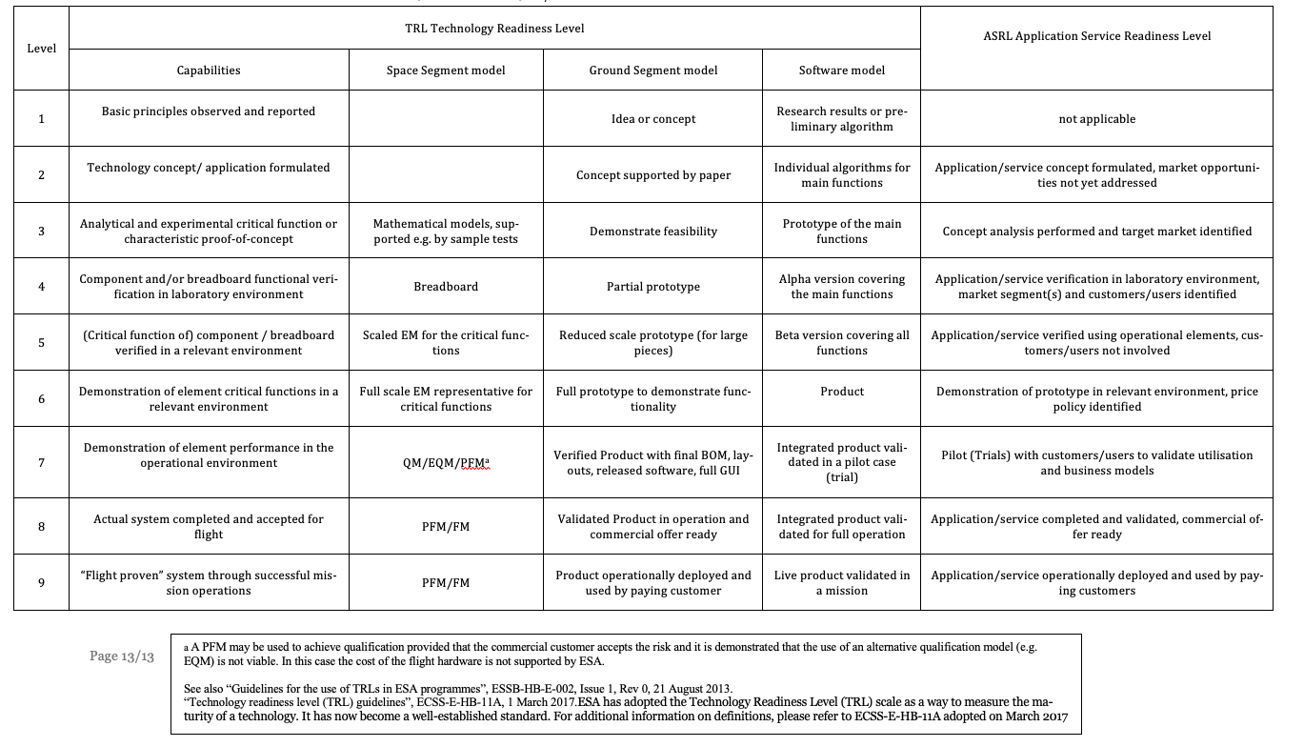
Service Obtainable Market (SOM)
Look at Target Market

Serviceable Available Market (SAM)
is the portion of the total available market (A/the segment/s (i.e. definable subgroup)) that the product/s and/or service/s fills.

Sales, General and Administration (SG&A)
That part of a company's activities (and expenses) that is concerned with operations, sales, general and administrative functions.
Stakeholder
A stakeholder is a person or group with an interest in a particular category of solution or service.
System
A functionally self-contained and integrated combination of hardware and/or software products, which represent the technological building blocks required to deliver a product/. The system, in its turn, can consist of a number of subsystems and equipment, representing a further breakdown of the technological platform.

System Requirements (SR)
Statement typically originated by the designer about what the system shall do and/or shall be to fulfil the User Requirements/Needs (e.g. associated to constraints, environment, operational and performance features). (The “HOW”).
Target Market
is the percentage of the serviceable available market that a company aims to capture in the short term
Time to Market
An expression of the time period for a product/ to be ready for use by users and paid by customers.
Time to Revenue
An expression of the time period for a product to go from inception to revenue stage (i.e. when it will start generating revenue from customers).
Total Available Market (TAM)
or Total Addressable Market, is the total market demand for a product or service. I represent the revenue opportunity available for a product/s and/or service/s. It counts the total of all unit sales of all competing product/s and/or service/s

Traceability Matrix
Verification method used to check that the set of elements A is correctly translated and matched to the set of elements B. For instance, URs to SRs, or Tests to SRs.
Turnover
Turnover is the total/gross amount of sales for a given product, service or company. Turnover is also a term used to describe Revenue.
Use Case
Formal description of steps or actions between the user and the product; usually represented by detailed diagrams (e.g. Unified Modeling Language, UML).
User
A User is a person or group with interest in utilising the product to be developed and involved in its validation. Users are often confused with commercial customers, but they are not necessarily the same thing. For example, a rail operator that purchases a product/ to deploy on its trains is the customer, while the passengers on the trains who use the product are the users.
User Need
A qualitative improvement as desired and expressed by the user, not necessarily verifiable.
User Requirement (UR)
Statement originated by the users describing the functions, performance and capabilities that the product will bring to them during its utilisation (the “WHAT”).
Validation
Process which demonstrates that the product is able to accomplish its intended use in the intended operational environment. The user shall have a key role in this process. Validation addresses whether a product will satisfy the needs of its users.
Validation proves it is the right product.
Value Chain
An informal set of organisations that participate together in an ecosystem to satisfy the needs of users and other stakeholders. Organisations participate at specific levels of a Value Chain to add capabilities to complement other components or solutions in the chain. Companies in a Value Chain look to collaborate with other members of the same chain in areas such as marketing, sales, and development.
Value Map
A visual tool used to show the competitive advantage of a solution showing ow you differentiate from competitor/s highlighting the difference from your product features

Value Proposition
Also called the Value Statement. This is a statement of the value that a company or solution offers to its customers and/or partners. A Value Statement is expressed from the perspective of the value to the target customer and addresses the main benefit derived by the use of the product.
Verification
Process to obtain confirmation that a system has been implemented according to the System Requirements (has it been produced according to the design). This is usually done through a verification method. Users are not involved in the Verification.
Verification proves the product is right.

