Project Name
Validation Plan
ESA Template Ver.1.0, Issue date: 27Oct2022
Approval
Title: Validation Plan
Issue Number: | Revision Number:
Author(s): | Date:
Approved by: | Date of Approval:

Change Log
Reason for change | Issue | Revision | Date

Change Record
Issue Number: | Revision Number:
Reason for change | Date | Pages | Paragraph(s)

Distribution
Name/Organisational Unit:

Table of contents:
1 Introduction 4
1.1 Reference Documents 5
1.2 Applicable Documents 5
1.3 Acronyms 5
2 Users And other stakeholders 5
2.1 Users group description 6
2.2 Product/service utilisation description: users and users’ group roles 6
3 Terms and Conditions for the Validation Operations 6
4 Conditions to start the validation and Utilisation Baseline for the Validation Operations 7
4.1 Conditions to start the Validation 7
4.2 Validation Set-up process 7
4.2.1 Acquisition of the users 7
4.2.2 Site installation process (if applicable) 8
4.3 Utilisation Baseline 8
4.4 Validation planning summary 8
4.5 Mitigation plan in case of delays 8
4.6 Validation Operation Summary Report 8
PROCESS for the Assessment of the product/service 9
4.7 Methodology 10
4.8 Validation objectives 10
4.9 Key Performance Indicators 10
4.9.1 KPIs characteristics 10
4.9.2 KPIs definition 10
4.9.3 KPIs summary table 12
4.9.4 Other important KPIs 12
5 Reports and evaluation 12
6 Exceptions Handling 13
7 DIGITAL MEDIA REPORTING 13
8 Conclusions 13
9 Annexes 14
9.1 ANNEX 1 (Questionnaires) 14
9.2 ANNEX 2 (Agreements) 14

Introduction
The Validation Plan (VP) is a practical guide to how the validation activities/pilot shall be run. It demonstrates that the consortium has thought about the practical consequences of taking the product and services to the field. The Validation stage of the project is one of the most hectic parts of the project and it’s easy to lose track of the objectives when trying to solve urgent issues. That’s where the KPIs come in. They help keep you focussed on what things are important, like getting great customer feedback scores and making sure that the product/service is used as much as possible during the validations activities.

This template structures the minimum requirement of content expected in the Validation Plan deliverable to be reviewed by the ESA during the project execution.

Concerning the use of this template, please note the following:

- Material presented in this plain style is either suggested content for the Validation Plan, or describes the content to be inserted in the corresponding paragraph, as relevant. This is intended to be an example of a response to the related Agency requirements, which the Contractor needs to properly complement. The suggested material may be adopted as is, or modified at the Contractors’ discretion. It remains the responsibility of the Contractor to ensure that all of the Agency’s requirements are properly addressed.
- This style is used to identify information that must be modified and/or completed by the Contractor for the proposed activity. This supplementary information should be presented in plain typeface (i.e. not red) in the final version of the Validation Plan.
- This style is used for explanatory notes and guidance to help you to develop the Validation Plan (e.g. to indicate a selection between mutually-exclusive options). This information should be removed from the final version of the document.
PLEASE, REMOVE THIS TEXT BOX AFTER YOU HAVE STARTED USING THIS TEMPLATE

Reference Documents
Ref. | Document ID. | Title | Rev.

Applicable Documents
Ref. | Document ID. | Title | Rev.

Acronyms
Tag | Description
VP | Validation Plan

Users And other stakeholders

Describe the actors in terms of the organizations or group of users (called user group in this context) that will be involved in the validation activities/ pilot operations and describe the service provided (or the service validation process) and the associated roles by the different participants (developer, service providers, suppliers, users, stakeholders, as applicable). If the user group and customers are different, take it into account.

A graphical representation of the different stakeholders can help to identify the key actors (e.g. in terms of organisations and individuals) involved in the service value chain, and the subset involved in the pilot operations. This is shown in the diagram below:

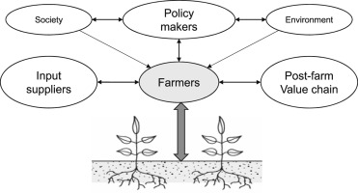
Figure 1 Stakeholders map (example) - in grey colour, the actors involved in the Pilot Operations

Users group description

Among the actors that will be involved in the pilot operation identified in the previous paragraph select the user group that will be involved in the pilot operations.
Identify what customer segment they are representative (in case the customer segments and use group do not match and their relation is not straightforward) explaining the reason for involving them in the assessment of the preoperational demonstration. You could create a mapping like in the table below.

 | User group 1 | User group 2 | ...
Customer Segment 1 |  | X | X
Customer Segment 2 | X |  | X
... |  | X

Describe the product/service that will be validated with the user group during the pilot stage.
In case there are more user group and more products/services a mapping like that in the table below shall be provided

 | User group 1 | User group 2 | ...
Product/service 1 |  | X
Poduct/service 2 | X
...

Product/service utilisation description: users and users’ group roles
Describe the pre operational services as they will be provided during the validation, and the way it is supposed to be utilised by the users. In case of necessity provide the different roles the users will have to play during the pilot:
- User group 1
  - Role 1.1
  - Role 1.2
- User group 2
  - Role 2.1

Terms and Conditions for the Validation Operations
Describe the formal agreements between the Contractor and the group of users involved in the Pilot Operations. The conditions for utilising the product/service (e.g. access to the helpdesk, commitment by the group of users to fulfil the utilisation plan and to contribute to the evaluation, security policy) and the associated administrative provisions (e.g. insurances, responsibilities, liabilities) shall be indicated. Formal agreements signed by the users shall be included in the document (in annex).

In order to participate the validation users must sign the Agreements Contract describing the formal agreement between the product/service provider and the users. The guidelines can be divided in product/service provider commitments and users’ commitments:

- product/service provider Commitments:
  - Commitment 1
  - Commitment 2
  - ...
- User commitments:
  - Commitment 1
  - Commitment 2
  - ...

Conditions to start the validation and Utilisation Baseline for the Validation Operations
Describe the conditions to be met to start the validation stage: the validation set-up process, a quantitative baseline of utilisation of the product/service and the associated planning, the validation planning and the Validation Operations Summary Report (VOSR) template.

This section describes:
- The conditions to be met to start the validation stage (e.g. formal authorisation to install and operate the platform, approval by specific committees)
- The validation set-up process
- The quantitative baseline of utilisation of the product/service
- The validation planning summary
- The mitigation plan in case of delays
- The Validation Operations Summary Report (VOSR)

Conditions to start the Validation
Describes the objectives to be met as pre-requisite to start the validation operations. Some examples are listed below:

- XXX images available for the validation of the product/service related to user group 1
- YYY users available for the validation product/service related to user group 2
- Tools for reporting and evaluation (e.g. log, utilisation statistics, technical status of the validation, questionnaire on line)
- Operational procedures in place (e.g. Helpdesk, activity monitoring, escalation in case of under-utilisation)

Validation Set-up process

Acquisition of the users
Describe the process of acquisition of the users.
The users acquisition objectives are
- User group 1: X agreement signed/week starting from dd/mm/yy until XXX is reached.
- User group 2: Y agreement signed/week starting from dd/mm/yy until YYY is reached.
- ...
Note that in some cases agreements with the User groups can be reached before the validation preparation starts.

Site installation process (if applicable)
Describe the process of installation of something that maybe needed (e.g. in-situ sensors, antennas, etc)
The objectives are:
- Z sites installed /week starting from dd/mm/yy until ZZZ is reached.
- W sites installed /week starting from dd/mm/yy until WWW is reached.
- …

Utilisation Baseline
Describe the quantitative committed baseline of utilisation of the product/service (e.g. number of utilisation sessions, volume of data to be analyzed, duration of interactive sessions).
product/service Usage:
- User group 1: minimum usage (unit to be defined )
- User group 2: minimum usage
- …

Validation planning summary

Put the dates associated to the validation set-up process, and the validation operation.
An example of a planning is composed of the following steps:
- Acquire the validation users of the different users’ group: deadline = dd/mm/yy
- Install the necessary equipment: deadline = dd/mm/yy
- The validation stage shall operate X months: dd/mm/yy
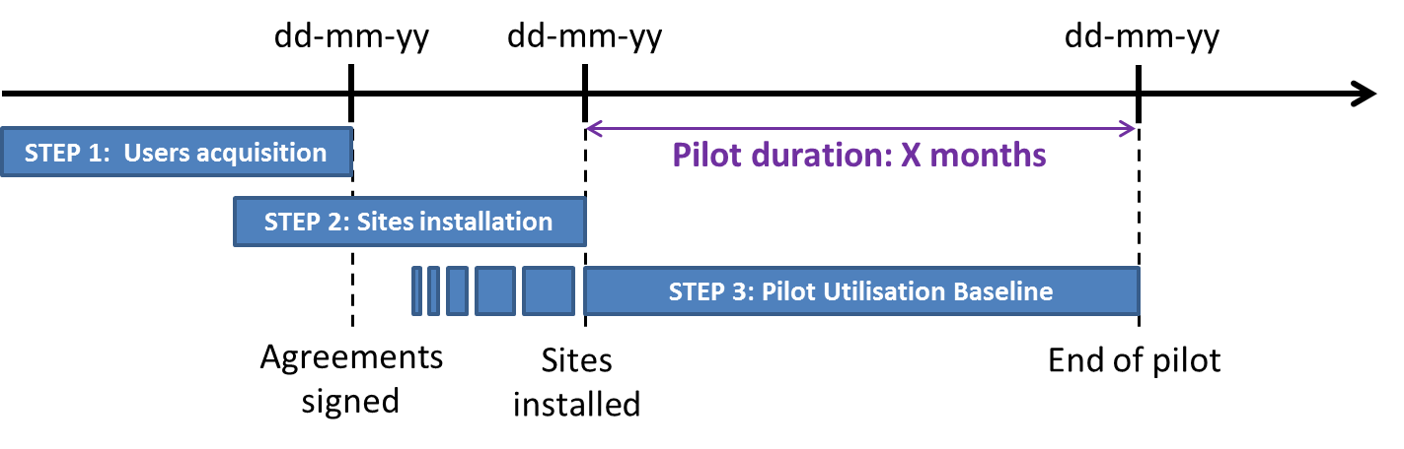
Example of dates and steps with corresponding objectives

Mitigation plan in case of delays
Describe the corrective actions you will perform in case of delays in the planning.

Validation Operation Summary Report
Describe the structure of the VOSR as it has been customised to the specificity of the project. If alternatives tools rather than the VOSR are available, their use within the project shall be discussed with the ESA project technical officer (TO).

In case many users will be involved in the validation, the following parameters shall be monitored in the user’s acquisition process before the validation starts.
- Users acquired each week
- Site installations completed each week

These shall be compared with the conditions to start the validation operation. Below an example on how to monitor this in the VOSR:

Example of captured objectives in blue and green

The VOSR file can be downloaded from this link

PROCESS for the Assessment of the product/service
This part describes the process that will be used to assess the project outcomes through the added value of the product/service. It defines the means to monitor the outcomes along the validation stage.

- Define the objectives of the validation (list of high level objectives technical, business, etc.)
- Identify the KPI and associated metric to assess whether the objectives have been met
- Map each objective to one or more KPI
- Identify an expected value for each of the KPI
- Describe tools and procedures to collect the value of each KPI

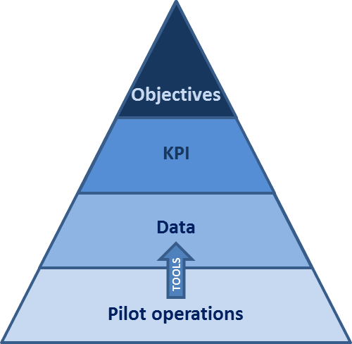
Methodology
The validation stage is used to validate the developed product and associated services in a representative context. This will allow to verify if the objectives of the project have been met.
The KPIs are defined as (possibly) quantitative indicator to verify whether the objectives of the validation have been achieved.
To determine these KPIs, data is extracted during the validation operation. This can be different kind of data such as images analyzed per unit of time, feedback from the users, time saved in the daily operations, value recovered. This data is extracted thanks to different tools (measurements equipment’s, questionnaires, logs, etc.)

Validation objectives
The objectives of the validation are ...
- First objective:
- Second objective:
- ……:
The validation objectives shall be put in relation to the eventual objectives of the whole project.

Key Performance Indicators

KPIs characteristics
The KPIs should reflect the validation objectives as identified above. All KPIs should have:
- A precise definition of its signification
- A defined metric: the data should have a measurable way to be captured along the process
- A timing: when the data should be monitored, at which frequency is measured and at which reporting frequency is made available to ESA
- A target: an expected value along time
- A process that allows to monitor it: a software tool, a mathematic formula, a procedure agreed with the users

The ability to visualise the results of these KPIs via a web interface would be the best way to publish them, alternatively they can be monitored in a worksheet within the VOSR (as done in the VOSR Template).

KPIs definition
The following KPIs will be considered:
- Objective 1
  - KPI 1
  - KPI 2
- Objective 2
  - KPI 3
  - KPI 4
…..

KPIs shall be measured during the validation operation; if they will be measured at the end of the validation itself a justification should be provided. Ideally KPIs could be reported in the VOSR associating them to each day of the validation operations.
KPIs linked to the utilisation of the product/service (e.g. number of sessions, number of users using the product/service) shall be measured incrementally, on weekly basis, and promptly reported to ESA in the VOSR submission.

KPIs summary table
A summary of the KPIs and their characteristics is shown on the template below:

 | KPI | Definition | Expected Value | Report Frequency | Period | Tool to extract the data
Objective 1 | KPI 1 |  | 80% answered 3+ to question 5 | weekly | During the validation, end of the validation | Questionnaire
 | KPI 2 |  | XXX | monthly | End of the validation | Software
Objective 2 | KPI 3
 | KPI 4
Objective 3 | …

Other important KPIs
There could be some other KPIs which have to be monitored during the validation but which have not direct relationship with the project objectives. Such KPIs shall be anyhow monitored and they should be structured with the same previous approach.

Reports and evaluation
This section will include the evaluation reports of the validation associated to the analysis of each KPI. Here the validation results have to be analysed from the users as well as the service provider’s perspective. For each KPI the team shall assess whether the objectives have been met or not, providing an analysis and consideration on what measured.

Each KPI will be extracted from the VOSR (or any other available tool). It is up to the contractor to decide how to monitor the KPIs along the validation stage (e.g. web interface or VOSR template for the KPI tracking)

Exceptions Handling
Whenever a significant underperformance episode (e.g. deviation more than 30%) occurs between the measured KPIs and the respective targets for two consecutive weeks, a specific analysis shall be carried out by the coordinator of the Validation Utilisation to identify possible causes and propose corrective actions.

The underperformance episodes described above shall be reflected into the Risk Analysis either with a new Risk Item (in case the issue was not already covered by the pre-existing risk items) or contribute to the analysis of the relevant existing Risk Item(s).

DIGITAL MEDIA REPORTING

The visual documentation of the validation operations is a key element which requires adequate attention. For this purpose, the Contractor is invited to document the process of installation, verification, validation and dissemination that will occur in the frame of the project. These images can be used by the company in future dissemination/marketing activities.

Conclusions
The validation results shall be summarised, providing an overall conclusion on the validation outcomes.

In order to promote and disseminate the results of the validation, a summary of the validation results shall be prepared as a contribution to dissemination materials (like brochures or presentations). The validation results shall be summarized, providing an overall conclusion on the validation outcomes.

Annexes

ANNEX 1 (Questionnaires)

An example of a questionnaire is provided by the System Usability Scale (SUS), see:
https://www.usability.gov/how-to-and-tools/methods/system-usability-scale.html

ANNEX 2 (Agreements)
This annex shall provide the agreement with the validation users….

