Validation Operations Summary Report
V.1.0 (27Oct2022)

- Introduction
The purpose of the Validation Operations Summary Report is to track the use of the product or service by the Validation Users/Customers. This form is part of the monthly report and during the validation stage you should deliver to the ESA Technical Officer an update of this form to show how the validation is progressing.
The Validation stage is one of the most difficult parts of the project to manage. When the system is being used by several users it’s difficult to control, and it is also complex fix issues. Validation users might be less active than they originally promised and it may be necessary to phone them in order to check how often they are using the system. Advice: The validation can go wrong quickly if not carefully tracked and managed. This can lead to delays if you are not very active in monitoring how the system is being used.
- Software dashboard
Instead of tracking the KPIs (as defined in the VP document) for tracking the validation progress it may be possible to use an online dashboard.
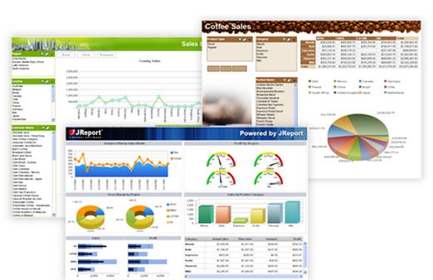
Credit Kate07lyn - Jinfonet Software
The dashboard may already exist or you can build a simple web page from existing data elements. You will need to give the URL and login to the ESA Technical Officer. You should make sure the you have obtained permissions from the Validation Users to share data to ESA.
- KPI table
As an alternative to the online dashboard.

Validation Summary Report
TEXT IN RED HAS TO BE REPLACED WITH THE RELEVANT ENTRIES]
Option 1: The URL to view the dashboard is https://www.esa.int and the user name is XXXXX (replace red text).
Option 2: KPI table (replace red text)
Definition | Measured how? | Expected result | Jan 2021 | Feb 2021 | March 2021 | April 2021
KPI 1  Number logons per user per month | Website logs | 10 users logon 4 times per month =40 total | 30 | 35
KPI 2  Temperature measured 4 times per day per unit and sent to server- no loss of readings | Server log | 4*number of days in month*10 devices | 1240 | 1120
KPI 3  Time spent logged in per user per month | Website analytics software | 15minutes*10 users =150minutes | 130minutes | 170minutes
KPI 4  System usability score of 70% measured in last month of validation | Email questionnaire and follow up phone call to chase response | >70% | 55% | 75%
KPI 5  Two customers ask for quotations for commercial service | Number of provided quotations | 2 | 1 | 1
Comments |  |  | Called ACME company to encourage testing | Customer Rick asked for quotation

